**Experiment—1:** Setting Up and Basic Commands Initialize a new Git repository in a directory. Create a new file, add it to the staging area, and commit the changes with an appropriate commit message.

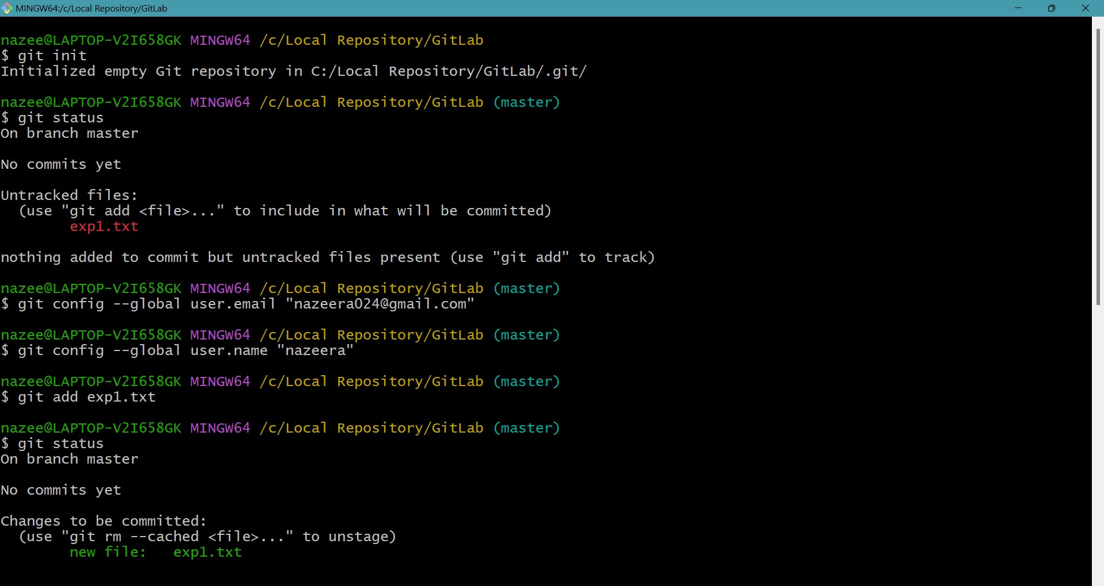

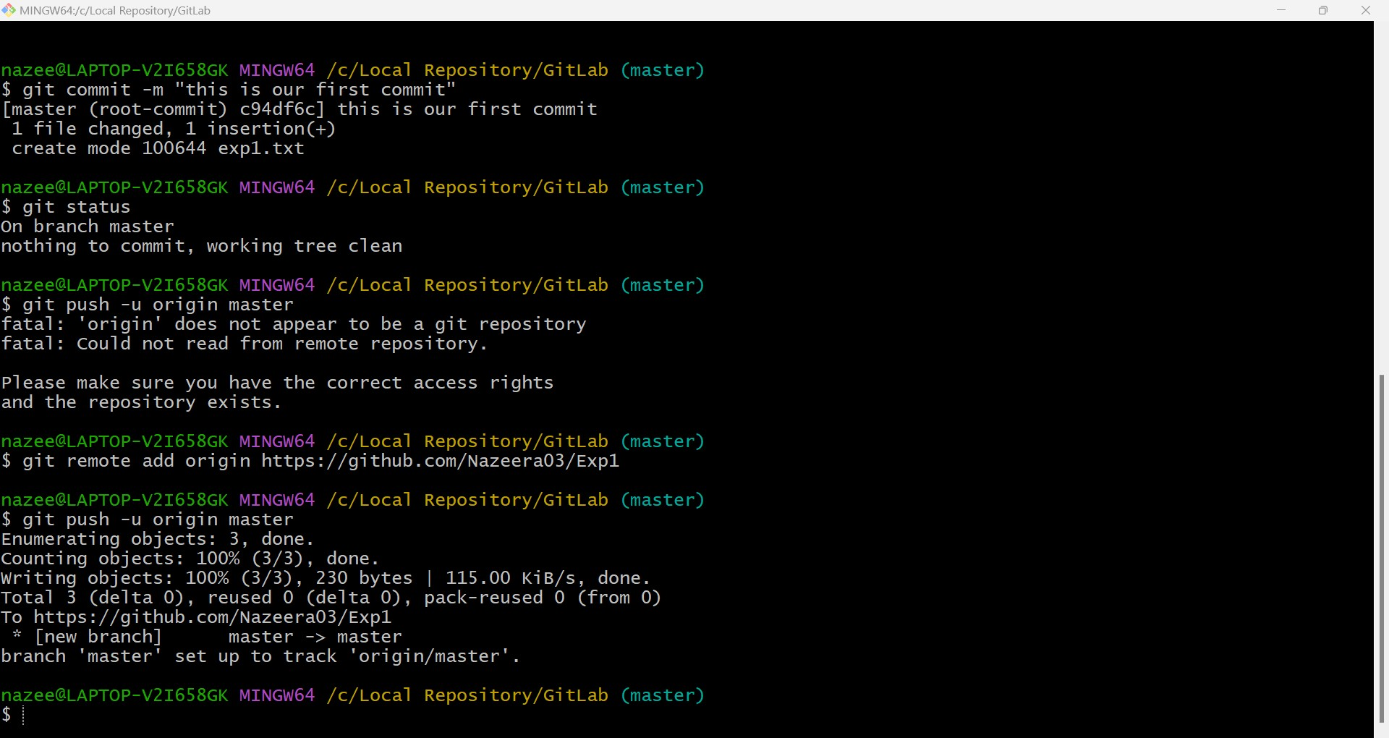

nazee@LAPTOP-V2I658GK MINGW64 ~

$ git --version

git version 2.46.0. windows.1

nazee@LAPTOP-V2I658GK MINGW64 ~

$ d:

bash: d:: command not found

nazee@LAPTOP-V2I658GK MINGW64 ~

$ mkdir e1

nazee@LAPTOP-V2I658GK MINGW64 ~

$ cd e1

nazee@LAPTOP-V2I658GK MINGW64 ~/e1

$ git init

Initialized empty Git repository in C:/Users/nazee/e1/.git/

nazee@LAPTOP-V2I658GK MINGW64 ~/e1 (master)

$ git status

On branch master

No commits yet

nothing to commit (create/copy files and use "git add" to track)

nazee@LAPTOP-V2I658GK MINGW64 ~/e1 (master)

$ nano e1.txt

nazee@LAPTOP-V2I658GK MINGW64 ~/e1 (master)

$ git add e1.txt

warning: in the working copy of 'e1.txt', LF will be replaced by CRLF the next time Git touches it

nazee@LAPTOP-V2I658GK MINGW64 ~/e1 (master)

$ git add .

nazee@LAPTOP-V2I658GK MINGW64 ~/e1 (master)

$ git status

On branch master

No commits yet

Changes to be committed:

(use "git rm --cached <file>..." to unstage)

new file: e1.txt

nazee@LAPTOP-V2I658GK MINGW64 ~/e1 (master)

$ git commit -m "committing a text file"

Author identity unknown

*** Please tell me who you are.

Run

git config --global user.email "you@example.com"

git config --global user.name "Your Name"

to set your account's default identity.

Omit --global to set the identity only in this repository.

fatal: unable to auto-detect email address (got 'nazee@LAPTOP-V2I658GK.(none)')

nazee@LAPTOP-V2I658GK MINGW64 ~/e1 (master)

$ ^C

nazee@LAPTOP-V2I658GK MINGW64 ~/e1 (master)

$ git config --global user.email "nazeera024@gmail.com"

nazee@LAPTOP-V2I658GK MINGW64 ~/e1 (master)

$ git config --global user.name "nazeera"

nazee@LAPTOP-V2I658GK MINGW64 ~/e1 (master)

$ git commit -m "committing a text file"

[master (root-commit) 83ae36f] committing a text file

1 file changed, 2 insertions(+)

create mode 100644 e1.txt

nazee@LAPTOP-V2I658GK MINGW64 ~/e1 (master)

$ git config --global user.email "nazeera024@gmail.com"

nazee@LAPTOP-V2I658GK MINGW64 ~/e1 (master)

$ git config --local user.name "nazeera"

nazee@LAPTOP-V2I658GK MINGW64 ~/e1 (master)

$ git remote add origin https://github.com/Nazeera03/e1

nazee@LAPTOP-V2I658GK MINGW64 ~/e1 (master)

$ git push origin master

nazee@LAPTOP-V2I658GK MINGW64 ~/e1 (master)

$ git push origin master

nazee@LAPTOP-V2I658GK MINGW64 ~/e1 (master)

$ git push origin master

info: please complete authentication in your browser...

Enumerating objects: 3, done.

Counting objects: 100% (3/3), done.

Writing objects: 100% (3/3), 231 bytes | 115.00 KiB/s, done.

Total 3 (delta 0), reused 0 (delta 0), pack-reused 0 (from 0)

remote:

remote: Create a pull request for 'master' on GitHub by visiting:

remote: https://github.com/Nazeera03/e1/pull/new/master

remote:

To https://github.com/Nazeera03/e1

* [new branch] master -> master

